850nm 100mw IR Laser Pointer pen
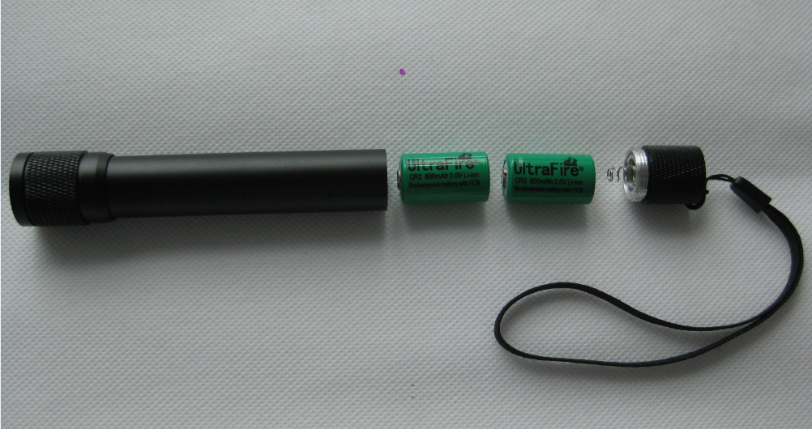

Power supply: 2 x CR2 3V Li-ion Recharged Battery

